Steps to reading music
- First decide – is the note you are trying to play is
a “LINE” note 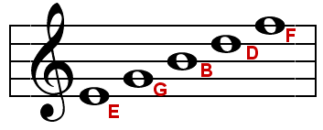 ( Treble clef line notes) 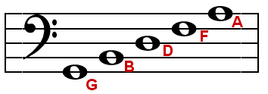( Bass clef line notes)

or is it a “SPACE” note 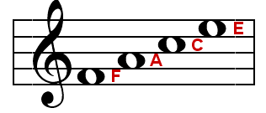 ( Treble clef space notes) 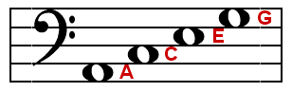 ( Bass clef space notes)

- Second decide what “NUMBER” line or space the note is on.
All music is read from the “STAFF” which is made of five lines and four spaces.
This applies to both Treble & Bass clef. Music is read from bottom to top and we number the staff from bottom to top.

Ex.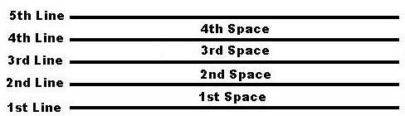

** Sometimes music is written beyond the five lines and four spaces using something called “ledger lines or spaces”. These notes are above or below the regular staff and we continue the musical alphabet in the order that we left it from the regular staff. Ex.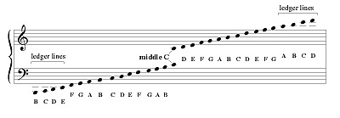

- Thirdly, now that we know what number line or space the note lives on the musical staff or ledger lines we can now match the note to our fingering chart.
** REMEMBER to look at your “KEY SIGNATURE” and at any “ACCIDENTALS” as this will change the fingering of the note.

Key signature- comes before the (time signature- (4/4, 2/4, ¾ etc) ) and tells us what flats or sharps there will be in the music.
Accidentals are Natural signs Sharp signs or flat signs that come directly before a note and change or alter the key signature FOR ONLY 1 ENTIRE MEASURE… and then the song goes back to its original key signature.
Ex.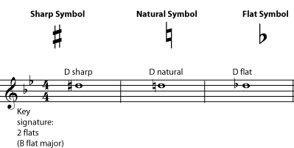 Accidentals change the letter D to sharp, D natural and D flat in the above example.

Sample Key Signature.

- Now that you know the letter name and the fingering you need to use, you must figure out the note’s rhythm. The rhythm tells us how long or how short to hold each note.
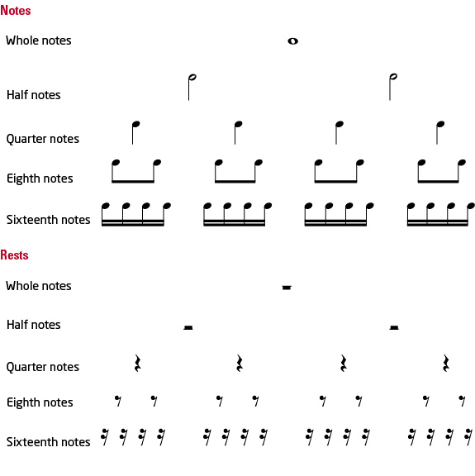

- Sometimes you will see other markings next to the notes or above the notes. These markings also tell us more about how to play the note, but what letter name we play is solely determined by the note’s place on the staff.
DOTS are something you will see a lot of in your music. There are TWO types of dots that you will come across frequently.
- The RHYTHM DOT
- The ARTICULATION DOT
The RHYTHM DOT is placed next to a rhythm that already exists. When the RHYTHM DOT is added, it adds ½ of the original rhythm’s value to the original rhythm making the new rhythm longer in duration.
Ex. 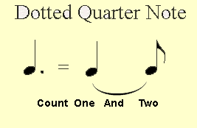
Quarter note = 1 count. The dot = half of the quarter note’s original rhythm which = ½
Thus, the dotted quarter note = 1 ½ counts. (equal to three 8th notes) we count it like this 1 and 2. Or three and four depending upon where it is in the measure.
Other versions of the rhythm dot we will see with a half note. If we add a rhythm dot to a half note the total value is 3 counts. ( because a half note 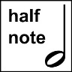 is equal to two counts normally. The dot adds half the value of the original half note which equals 1 count. We add 2 counts plus 1 count for the dot and we get a dotted half note = 3 counts.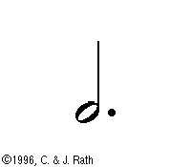
The Articulation Dot is NOT added to the side of the rhythm. It is found above or below the note and it is responsible for changing the way we attack the note with our tongue. It does not change the note’s letter name nor does it change the duration of the rhythm only how we attack the note.
The articulation dot has a name- it is called “Staccato” we used the syllable “Dut” to make the notes short sounding and crispy sounding while still counting the same rhythm that was written.
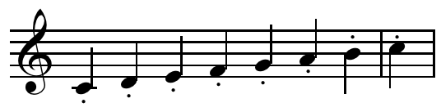
SLURS VERSUS TIES THE SLUR – another marking you may find in your music- connects two different letter names together (only tongue the first note and move your fingers without re-tonguing for the second note).Ex. 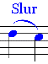
THE TIE - - the tie looks like a slur but the DIFFERENCE is that the tie connects two of the same letter names extending their rhythm length. Ex.